Google Chrome Developer Tools Crash Course

Traversy Media – Technical Educational Media

<https://www.youtube.com/watch?v=x4q86IjJFag>

timer: 9:00

opening dev tool – F12, ctrl + shift + I, 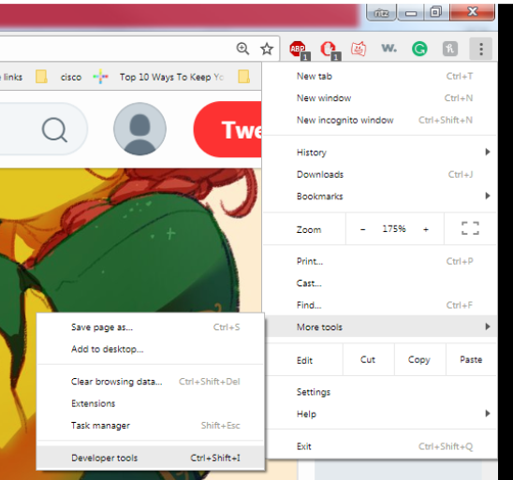

working with in menu:

elements, console, sources, application